Dis-Can-NW-Haida-Humpback Whale Carving

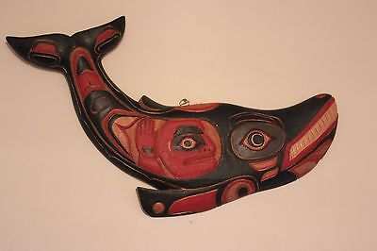

**Formal Label: Canada** Haida Humpback Whale Carving

**Accession Number:**

**LC Classification:** E 99.H2

**Date or Time Horizon:** 20th century

**Geographical Area:** British Columbia.

**Cultural Affiliation:** Haida

**Medium:** Cedar

**Dimensions: L 39 cm; W 25 cm  
Weight:**

**Provenance: Haida**

**Condition:** Museum quality.

**Discussion:** Whales are believed to offer themselves up as food to help the people survive, and therefore hold a special position of honor and respect. Men who were successful whalers were among the highest-esteemed members of traditional Northwest Coast societies. This visual rendition of a humpback whale has a human-fish in his belly as his captive as in the Jonah story.

**References:**

Wright, Robin K. 2001. *Northern Haida master carvers*. Seattle, WA: University of Washington Press.